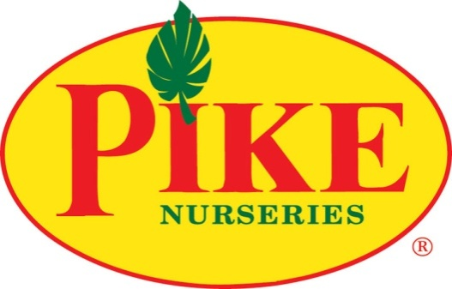

MORE INFORMATION
Shaye Gulotta
BRAVE Public Relations
404.233.3993
sgulotta@emailbrave.com
FOR IMMEDIATE RELEASE
Pike Nurseries offers advice for picking the perfect pumpkin
Horticulture experts help gardeners decorate for the season with fall Do-It-Yourself projects
ATLANTA (September 28, 2020) – It’s a pumpkin palooza at Pike Nurseries! This October, the Southeast’s favorite garden center gets a jump start on fall traditions with pumpkins varieties in all shapes and sizes. The experts recommend planning ahead for a pumpkin’s use – whether carving or cooking. Carving pumpkins are desired for their nice shape and smooth surfaces, whereas cooking pumpkins are known for their flavor and texture. The centerpiece for fall décor, long-lasting heirloom pumpkins and gourds are used for seasonal displays in homes, gardens and tabletops throughout the season.

When selecting a pumpkin or gourd, the experts at Pike Nurseries recommend looking for a firm option without cuts, soft spots and darkening bruises or blemishes – all signs of rot that will make the pumpkin decay more quickly – and avoid carrying them by their delicate stems. Gardeners should look for deep orange colors for the skin and green for the stems.

Pumpkins Varieties
No matter the purpose – carving, decorating or cooking – there’s a perfect pumpkin for the job.

- Classic Orange
The tried-and-true carving pumpkin is a classic staple of the season! Look for individual pumpkins free of imperfections on at least one side that make a hollow sound when tapped. Large pumpkins will maximize creativity and give more of a canvas to work with for jaw-dropping Jack-o’-lantern designs – from scary to silly. Pike Nurseries makes decorating at a discount simple with the All-You-Can-Carry Pumpkin Challenge, where guests are invited to carry as many medium-sized classic orange pumpkins as possible for only $24.99! Pike Nurseries employee-owners will be social distancing, so shoppers are encouraged to bring a family member to help stack.
- Heirlooms
Heirloom varieties are perfectly imperfect, offering a trendier approach to decorating. These popular pumpkins tend to be flatter on top, making them ideal for stacking, and have unique characteristics such as deep ribs and a variety of colors from white to gray-green to sunset red. Mix and match small and large heirlooms on tabletops, stoops or around fall container gardens for a festive display!
- Gourds
These relatives to the pumpkin offer a wide variety of options that enhance any display. With hundreds of types, including swan-necked, ridged and bumpy, gourds are a must-have for table and front door décor.
- Knucklehead Pumpkins
Create a creepy aesthetic with varieties that have naturally occurring flaws like wart-riddled and bumpy skin, resulting in a devious display! These can easily be added to traditional pumpkins or heirlooms in unique fall accents or used as unusual carving pumpkins.
- Pie Pumpkins
Don’t forget to grab a few for recipes! While most pumpkins are edible, the smaller ones are favored for pies and other pumpkin-flavored sweets because of the higher sugar content and thicker, softer flesh. Pie pumpkins are ideal for roasting, desserts, soups and more seasonal dishes – offering a nutritious treat without the tricks!

31 Days of Pumpkins
Pumpkins come in different shapes and sizes, lending to a vast range of uses and personalities. Simple Do-It-Yourself projects can transform pumpkins into festive indoor and outdoor arrangements. The experts at Pike Nurseries have outlined a few of their favorites to help get started:

- DIY Decoupage Pumpkins
Families can use the colorful foliage of fall clipped from the garden to create stunning decorated pumpkins. Consider color and texture when choosing leaves and pick a collection that will complement each other.
- DIY Succulent Pumpkin Planter
Succulent lovers can incorporate this waterwise plant in an heirloom pumpkin craft! Since the pumpkins won't be carved, this long-lasting DIY can grace porches or tables from Halloween to Thanksgiving.
- DIY Pumpkin Topiary
Decorators can play with different sizes and shapes of pumpkins to create a topiary that’ll fit the designated space and décor style.
- DIY Jack-o-Plantern
Gardeners can create a pumpkin planter by cutting open a pumpkin and planting favorite fall flowers and foliage inside! Be sure to read the recommended care instructions.

For more information on tips from the pros at Pike Nurseries, please visit pikenursery.com.
###
ABOUT PIKE NURSERIES
Ever committed to its customers’ gardening success, Pike Nurseries takes pride in taking the guesswork out of gardening and helping its customers play in the dirt. Offering superior knowledge, quality and selection in a friendly, caring environment, Pike Nurseries has been an Atlanta icon for over 60 years. Founded in 1958 by Pete Pike, its ability to adapt to market conditions and community needs has made it a respected Southern institution. As Atlanta’s oldest garden chain, Pike Nurseries has 18 retail locations in the Atlanta, Ga. and Charlotte, N.C. areas. Led by President Monte Enright, Pike Nurseries looks forward to continued growth as it keeps Atlanta and Charlotte beautiful, one landscape at a time.

Visit Pike Nurseries on Facebook, Instagram, Pinterest and Twitter.

